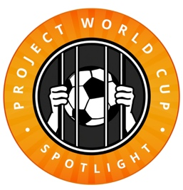

Kim Herdman Shapiro
Co-Founder, Project World Cup Spotlight
Kimhs@mac.com
603-943-7090
www.projectworldcupspotlight.org

FOR IMMEDIATE RELEASE:

Activists Declare Major Victory as ICE Scraps Plans for 7 "Human Warehouse" Detention Centers
Project World Cup Spotlight Celebrates Massive Blow to Inhuman Detention System, Vows to Escalate Protests for Remaining Facilities

BOSTON, MA– June 19, 2026 – Project World Cup Spotlight is today celebrating a major victory for human rights after ICE confirmed yesterday it is abandoning plans for 7 of the 11 controversial "warehouse detention facilities" it has purchased over the past six months. The move is a direct response to immense public and government pressure against the plan.
"We see this as a massive, hard-won victory against a cruel and unacceptable government policy," said Kim Herdman Shapiro, National Coordinator for Project World Cup Spotlight. "These buildings were built to store Amazon packages, not human beings. We view this victory against them as a testament to the power of citizen-led protest.”
While celebrating the win, the group stresses that the fight is far from over. Four of the planned warehouse facilities remain in the planning stages in Surprise, AZ; Hagerstown, MD; and both El Paso and San Antonio, TX. These four sites alone would add an estimated 5,000-6,000 beds to the ICE detention network.
"Even amidst this celebration, we cannot forget the larger crisis," Herdman Shapiro continued. "There are still over 60,000 people housed in detention centers across the United States in what author and journalist Andrea Pitzer has correctly identified as 'a modern concentration camp system.' This victory is a critical battle, but the war is not over."
To continue its campaign, Project World Cup Spotlight will stage major protests against ICE and the administration over the next four weeks. Protests are scheduled for the following cities:
- Atlanta
- Miami
- Philadelphia
- Houston
- Boston
- Los Angeles
- San Francisco
- Seattle
- New Jersey

About Project World Cup Spotlight:
Project World Cup Spotlight is a coalition of grassroots organizations, including 50501, Global Exchange, Visibility Brigade, and Indivisible chapters, using the global attention of the World Cup to expose, document, and protest the human rights abuses of ICE and the current administration
###

